MACROMEDIA FLASH MX

Duration of the course: 8 hours
- OVERVIEW

What is Flash? Flash is a program for designing graphic animations. It was specially created as a tool to publish graphics on the internet in a more efficient way: flash files download faster and with a better quality of image. You can also add interactive elements as for example buttons in a very easy way.

What will you learn? At the end of this course you will know how to import, modify and create graphics, to animate these graphics, and to create interactive elements. With this you can design animated introductions and banners for your websites or presentations and design buttons to surf around them.

- INDEX

1. To start working
- The workspace: what is what,
- Creating own graphics,
- Importing images to library,
- Testing the movie.

2. Animating graphics
- Tweening: a ball that crosses the screen,
- Guideline: a man that follows a path,
- Shape, size and turning: shapes that change,
- Fading: objects that appear and disappear.

3. Controlling the movie
- Setting Actions to frames and buttons,
- Creating buttons,
- Making links to web addresses.

4. Publishing
- The different formats,
- Protecting a movie.

Practice: designing your own…
- animation for an intro to a website or cd-rom,
- banner with buttons for a web page,
- animated graphic with a link to a section.

Real examples on the internet: all this and more you can do with Flash!

Learn more: This course will teach you the basics of Flash. If after you are interested in learning more, you will find step-by-step lessons for all levels in the Help of the program (Flash menu → Help → Lessons). The book from Katherine Ulrich Macromedia Flash for Windows & Macintosh (Peachpit Press, 2002) is also very good.

- INTRODUCTION

How does Flash work? Flash works like a real movie. A real movie is composed of many photograms with a different image in each one, and watching them at a certain speed gives us the illusion of movement. Flash photograms are called “frames” and they are shown at an average speed of 12 frames per second. The good news is that you don’t need to paint every frame manually: the animation between two frames is done automatically. The frames that you create manually (frame 1 and 5 in fig. 1) are called “keyframes” and are shown as black points (fig. 3).

fig. 1
Besides, to help you organizing all the elements of a graphic, Flash works with layers. Each layer contains a different element from the same frame (layers from the same frame are shown together, fig. 2). Besides, you must use a different layer for every object if you want to animate these objects (important!). You can lock and hide each layer independently to work better, as well as name them and organize them in folders.

fig. 2

This means that you will have to work all the time with frames and layers. You can control them from the Timeline, which is directly in the workspace.
fig. 3

Another basic concept of Flash are symbols. A symbol can be just an image (“graphic”), an animated image (“movie clip”) or a button. However, not every image you draw is a symbol: you must convert it (fig. 4). Symbols are useful for two reasons: first, because they are better for animating images, and second, because you can reuse the same symbol as much as you want without making your file heavier. Every time you use a symbol you work on an “instance” of it, which you can edit without modifying the original symbol (fig. 5).
fig. 4, 5 and 6: we convert an image into a symbol, save it in the symbols library, and change the color in two instances of it.

Apart from this, it is good to know that one of the best features
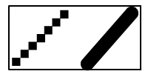 fig. 7
of Flash is that in the graphics it works with vectors instead of
bitmaps. This means that the graphics maintain the same quality
even if you make them bigger or smaller.

1- TO START WORKING
The workspace: important elements.

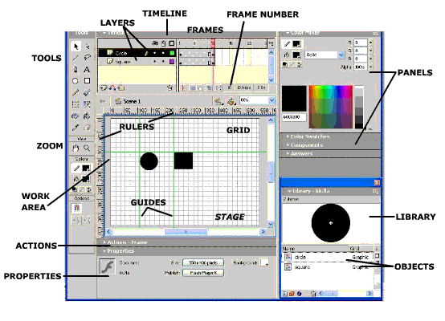 fig. 8

Stage (white area): The surface that will be published. You can change the size & color.
Work area: Unlimited space to work outside the stage (the objects placed there will not get published).
Grid: Optional squared grid to help you distributing the objects around (it will not get published). (menu → view → grid)
Guides: Optional lines that can be set following the rulers to place the objects at a specified height or width (they will not get published). (menu → view → guides / rulers)

Timeline: The access to the
objects of the movie along the
time using layers and frames.
Tools: All the tools you need to create, move, zoom and modify graphics and text.
Library: A list of all the symbols of your movie. It shows the name and the image.
Properties: A context sensitive panel with all the information of the object or the tool you have selected. It gives you direct access to modify its most common properties.
Actions: Flash has a built in programming language to set actions as for example stop, get url…
Panels: Different panels give you quick access to different elements of the program.
To hide and show elements: menu → window

The Toolbox: Useful Tools
Select | Draw Line |  | Text |  | Oval Figures
Square Figures | Pencil |  | Free Drawing |  | Resize & Turn
Paint Inside | Select Color |  | Erase |  | Move Screen
Zoom |  | Border Color |  | Inside Color

