Corel Photo Paint

Duration of the course: 6 hours.
• OVERVIEW

At the end of this course you will know:
- to create and import graphics,
- to work with and change pictures,
- to create banner and button graphics,
- to create animated GIF files.

With this course you can:
- Design buttons and banners for your websites and presentations with Front Page and Power Point,
- to create and rework graphics and pictures for a website.

• INTRODUCTION

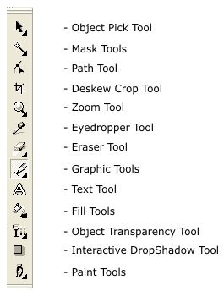
What is Corel Photo Paint? Corel Photo Paint is a program for working with pictures. It was specially created as a tool to rework and change pictures but in the same time to create graphics, to combine and integrate them in pictures or other graphics and it is very useful in creating banners and buttons for a Front Page theme.

LESSON 1 & 2
- Corel Photo Paint: how does it work?
- To get close to the program and its
- taskbars.
- The workspace: what is what?
- To find all necessary & useful Tools.
- How to create your working area?
- To create your page and fit it to your
- exact needs.
- Create easy shapes.
- Using the Graphic Tools to learn how
to handle shapes and to create the
first graphics with Corel Photo Paint.

To work with colors.
First step to choose the color
Modes, we will working with.
To get to know the world of Corel
Colors and learn to use the different
way of fillings, backgrounds, frame
and letter colors.

- We’ll take a digital picture of each one to prepare the next lesson.
Color Mode: Taskbar: Image/Mode Color Editor: Double click on
Taskbar: Fill tools

LESSON 3 & 4
- How to insert a picture?
To insert a picture or an icon and to bring it in the right working size.
- How to work with pictures?
To cut out some parts of the pictures, to work with it and save them as a new object.

- To change and rework pictures.
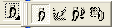

- Working with and Adjust pictures by using the effects and the Adjust Tool.

Taskbar: Effects/
3D Effects Art Strokes Blur Creative

Taskbar: Effects/ Taskbar: Image/ Adjust
Distort Texture

LESSON 5 & 6

- Making Photo collage
How to make a Photo collage out of as much pictures you like to.
- How to create a transparent gif file.
taskbar: Image/Stich…

Creating an animated Movie
How to create an animated gif
Button and banner for a
webpage.

